A Project Report

On

**Online News Management System**

Submitted as Partial fulfilment of BCA degree 2018-2019

From

Sardar Patel University, Vallabh Vidhyanagar

Hardip Ravalji

Guided By

Pritesh Pinakinbhai Rami Submitted By

Lecturer (B.C.A. SEMESTER IV)

DNICA, Anand. Exam No: -__________

Shri D.N Institute of Computer Applications

Managed By Charotar Education Society Anand.

**INDEX**

|  |  |  |
| --- | --- | --- |
| **Sr.No.** | **Description of Topic** | **Pg. No.** |
| 1 | **Introduction To The Project** | **3** |
| 2 | Scope of Work | **5** |
| 3 | Existing System | **6** |
| 4 | Need of Proposed System | **6** |
| 5 | Feasibility Study | **7** |
| 6 | System Features | **9** |
| 7 | Hardware and Software | **10** |
| 8 | Data Flow Diagram | **11** |
| 9 | Database Layout/ File Layout | **17** |
| 10 | Input Output Screen | **18** |
| 11 | Testing Procedures & Implementation Phases | **22** |
| 12 | Proposed Enhancement | **23** |
| 13 | Conclusion | **27** |

**INTRODUCTION OF PROJECT**

**The Theme of my project is Online News Management System.**

Now-a-days we live in age of Information Communication and Technology (ICT). We can’t think a single moment without technology. From morning to night, we need help of the technology. This is the revolutionary time of computer technology. Most of the works depends on web application. For this reason, anytime, anywhere, anyone can access a website by internet at low cost and we can find our expectable and most update information from website. At present information is one the most valuable resource of the current world. We have developed our project so that we can aware the people.

Administrator is responsible for updating the news details on computer. The administrator is the authorized user who has power to change and edit the updates as well as the password.

**Purpose of Online News Management System**

The purpose of the whole system is to ease the daily or regular news and activities into an automatic computerized retrievable process. The daily activities include the politics, Entering sports, science and technology, updating of news and to record the process in a **Computer system for future.**

Due to time constraint and the minimum resources the system is not made for the high level use. But the management system can use the application n very easy and minimum effort.

1. News updating

2. New user registration

3. News detail

4. User login

5. Feedback form

**Scope of work**

* The objective of this project is to develop a web application for Online News.
* Online website that can aware the people.
* The objective of this project is to provide the daily news.
* The objective of this project is to provide the breaking news.
* It makes use of various technologies to get required crime oriented information more quickly, easily, colorfully and attractively.
* To do this for more widely coverage of distribution and faster dissemination of information in a more timely manner.
* Anytime, anywhere, anyone can know about the news or information by internet at low cost. Dynamically provides facility.
* To add any new information without any complexity.

**An Existing System**

In this system, the customer can see the news papers and read all the news. This makes the work harder and the news paper is not available everywhere.

**Need of proposed System**

* + Here, the manual system to be computerized. Computerizing the existing system and producing the application with the help of some language and database package ease of the work of system.
  + Nobody works without detailed information nowadays. In the computerized system starts with splash windows and the login window. The initial step is to ask for a login name and valid password. The combination of password and login name is valid then only then the user to be allowed to enter the system.
  + Now after the person is allowed to enter in the system the next screen of the MDL form the main menu contain, the option of the operation, the person can add details of user, journalist record, news record.

**Feasibility Study**

Feasibility study is undertaken to determine the possibility of either improving the existing system or developing a complete new system. It helps to obtain an overview of the problem and go rough assessment of whether feasibility solution exists.

Need of feasibility Study:

* Answer the question whether a new system is to be installed or not?
* Determines the potential of existing system.
* Improve the existing system.
* Know what should embed in the new system.
* Define the problem and objective involved in a project.
* Avoid costly repairs at later stage.
* Avoid the hardware approach.

**Types of feasibility:**

1. Technical Feasibility
2. Economic feasibility
3. Operational Feasibility
4. **Technical feasibility**

Technical feasibility should ask related to:

* + Adequacy of available technology
  + Adequacy of hardware
  + Available of computer
  + Operating time and support facilities

Technical feasibility in the system deals with technology used in the system. It deals with hardware and software whether they are of latest technology or not. It is important because our system is prepared a new technology arise and user wants the system based on technology.

1. **Economical Feasibility**

“Economical feasibility is closed related to the project “Bank salary to place actual money value against any purchase or activities needed to implements the project. The supports plan to get the system and there is no interruption.

1. **Operational Feasibility**

An operational feasibility determines how the proposed system will fit in the current operation. In operational feasibility check whether your user is comfort with the work. If user does not understand the system further development.

**System features**

**There are different features of system are as follows:**

* Menu driven and user’s friendly.
* Provides data security.
* Interactive Processing.
* Avoid the duplication of information.
* More storage space available.
* Different types reports generated.

**Hardware Specification**

**Hardware Requirement of the system:**

This phase of the software development process deals with a brief study of different hardware use in the computerize system. There is a list of hardware materials used during the making and also during the use of the proposed system. As the new system to be made in to a computerized functional system, requirement of a computer is must. All the hardware needed here are generally the basic configuration of a typical office computer. A list of the hardware requirements used in the system given bellow.

**Minimum Configuration:**

Intel Dual Core Processor

1 GB RAM and Higher

50 GB HDD and Higher

Mouse

Keyboard

Monitor

**Software Requirement:**

The Minimum Software require by the proposed system is follows:

|  |  |
| --- | --- |
| **Operation System** | **Windows XP** |
| **Front-End Tool** | **ASP.NET** |
| **Back-End Tool** | **SQL Server 2005** |

**Data Flow Diagram / OOAD / UML**

The data flow diagram is the pictorial representation of the system study. The data flow diagram converts all the processes and the storage area which taxes places during any transaction in the system. The data flow diagrams are functionally divided into context, first level, second level data flow diagrams.

**Symbol used in DFD:**

* **Process:** Here flow of data is transferred. E.G. purchased of item. Update inventory file etc.
* **External Entity:** A source of destination of the data which is external to the system. E.g. Customer, suppliers etc.
* **Data Flow:** It is a packet of data it may be in the form of document, letter etc.
* **Data Store:** Any data will be stored, but no reference to the physical method of sortie.

**Context Level:**

**User**

**Admin**

Registration

Log in

View News

Log in Successful

Add New News

Log in

Response

Get Information

New User Detail

**Zero Level Diagram for User:**

Response

User

REG

NEWS

Authentication

Request

Successful

New User

Response

Log in Detail

User Detail

Updation

User Detail

News Detail

Updation

News detail

View Response

Write Comment

Request Fulfill

Registration Successful

Request News

**First Level for Login:**

Change/Forgot Password Successfully

**User/Admin**

**REG**

Request

Successful

Authentication

Response

Log in Detail

Change/Forget Password

Updation

Request for Change/Fogot

**First Level for View News:**

Response

Response

**User**

**News**

News Detail

Updation

Feedback Detail

Write / Comment Feedback

Get Information

News

Detail

**FEEDBACK**

Request News

**DATABASE LAYOUT:**

1. **USER**

|  |  |  |  |  |  |  |  |  |  |  |  |  |  |  |  |  |  |  |  |  |  |
| --- | --- | --- | --- | --- | --- | --- | --- | --- | --- | --- | --- | --- | --- | --- | --- | --- | --- | --- | --- | --- | --- |
| |  |  |  |  | | --- | --- | --- | --- | | **field Name** | **Data Type** | **Constraint** | **Description** | | Uname | varchar(30) | Notnull | User name | | Pwd | varchar(30) | Notnull | Password | | Mail | varchar(15) | Notnull | Email id | | Contact | Numeric | Notnull | Contact of user | |  |
|  |  |
| This table is to edit and view user.   1. **News**  |  |  |  |  | | --- | --- | --- | --- | | **field Name** | **Data Type** | **Constraint** | **Description** | | NID | varchar(30) | Notnull | News id | | Type | varchar(30) | Notnull | News type | | Yr | Numeric | Notnull | News year | | News | Varchar(100) | Notnull | Description |   This table is to add news and edit news.   1. **Feedback**  |  |  |  |  | | --- | --- | --- | --- | | **field Name** | **Data Type** | **Constraint** | **Description** | | Uname | varchar(30) | notnull | Username | | Msg | Varchar(100) | notnull | Message | |  |

This table is to add feedback.

**Input and Output Screen**

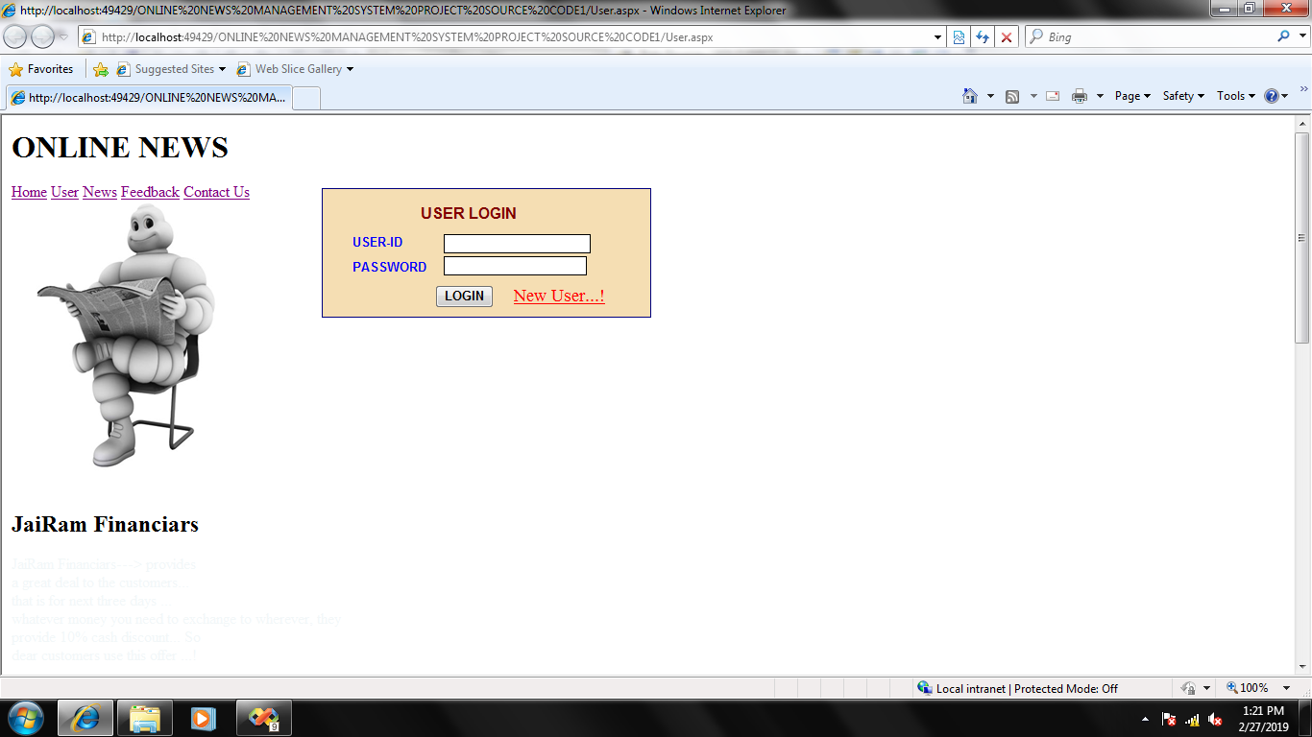

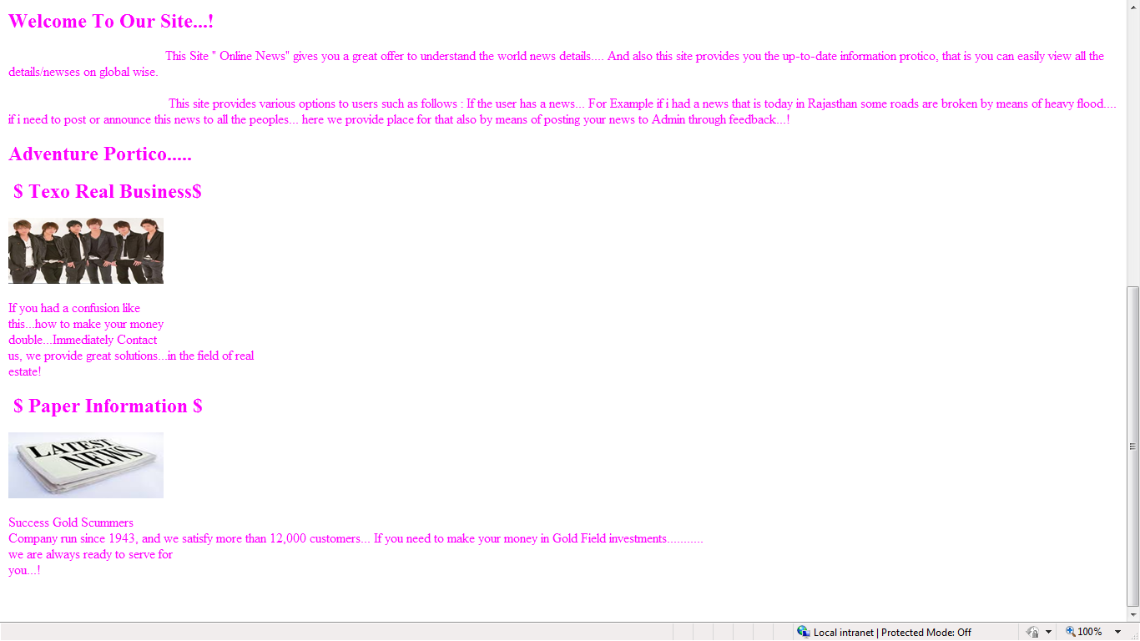

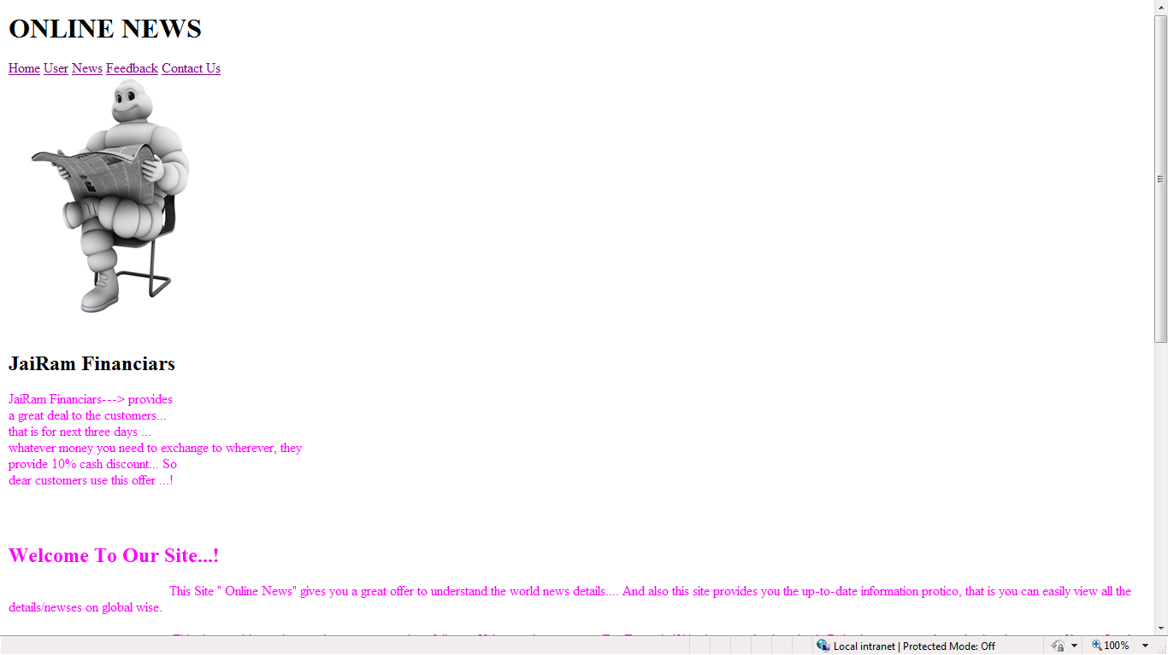

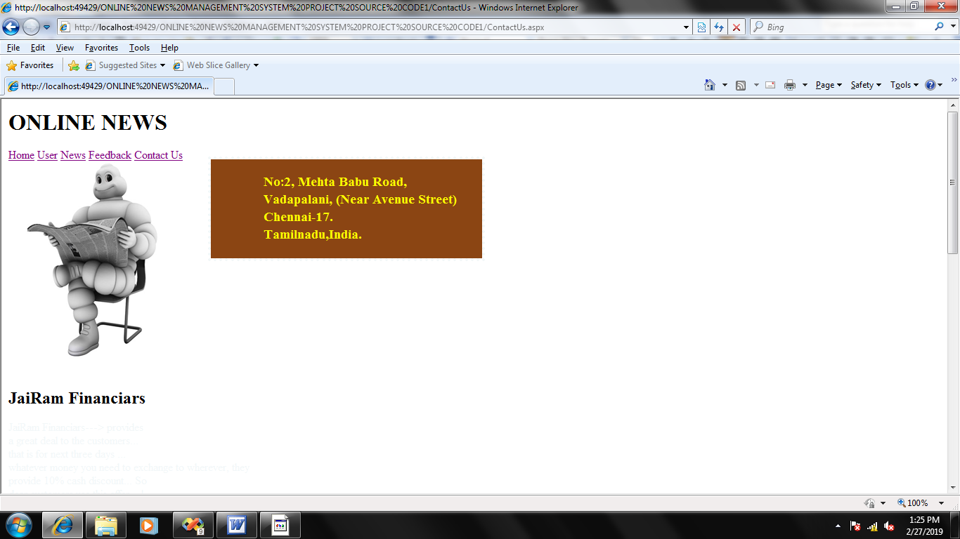

**Testing Procedures & Implementation Phases**

**Testing**

As testing forms the first step towards determining the errors in a program it should be properly carried out.

The website was tested keeping the following in mind.

* **Unit testing:**

Unit testing was carried out for each module against the specifications produced during the design of the module.

Unit testing of each program and module was done with the following perception.

**User interface**:

User interface was tested which gave rise to more user understandable errors and help messages.

**Internal logic:**

While testing a module, the internal logic was tested.

* **Integrated testing**:

Tint the integrated sting, the unit-tested modules were combined into subsystems and then tested.

The strategies for integrated tested comprised of:

* Performance time testing.
* Logical cycle of data.
* Test data.
* Live data obtained from users.

**Implementation**

* An automated communication system enables immediate updates, in case of any changes.
* The system helps the admin in taking appropriate and quick decisions. The system reduces the amount of paper work to a great extent as a result of which it is possible to engage the human resources in some other productive tasks.
* Implementation of the system produces accurate results with comparatively less time consumption.
* The system enables the establishment of an organization with efficient and effective intercommunication between different departments.
* We can add services as many we require. We have to implement business logic for that service and make the small change in the configuration file.

**SYSTEM EVALUATION**

Evaluation is nothing but feedback for the system. This is the third and final checkpoint of System Development Life Cycle (SDLC).

Natural evaluation of the system considers the strengths and weaknesses of the system, this includes

**Development Evaluation**

This decides whether the system is developed on time and within the budget. It also includes assessment of development methods and tools. Our system Online Education for Competitive Examinations is developed on time in the duration of 2 months and within the budget.

**User Management Assessment Evaluation**

How often managers use the information system and how far they are satisfied conclude the real worth of system. Our system is used by everyone and is worth making system.

**Operation Evaluation**

* This includes
* Response time
* Ease of use
* Reliability of computation
* Adequacy of storage capacity, etc.

The system is easy to use and everybody can access it easily as surfing on Internet. The system is password protected, so any unauthorized cannot access the system.

As the system is the web application, so everything is stored on the server which is located in the high secure area and no one can access.

The system shown on the web browser of any user is only client part and core code or the master code and the database file is safe on the server.

The data is stored centrally and so less storage capacity on the user side and server configuration on the server side is required.

**LIMITATION**

* More human power
* More strength and strain of manual labour needed
* Repetition of same procedure.
* Low security.
* Data redundancy.
* Difficulty to handle.
* Difficulty to update data.
* Record keeping is difficult.
* Backup data can be easily generated.

**Conclusion**

* It was a really good experience for us to do a project. Working on this project has given us a valuable experience. It has been like stepping on the first step of the staircase that leads us towards building our career. It was our first experience of working in the atmosphere of a software firm.
* At the time of practically executing our knowledge, we fortunate to have very cooperative and supportive project leaders and colleagues, their attitude towards us was very palliative and was always there in our needs.
* We also learnt have to college with other lecturers while working in the same project. This precious experience would definitely be helpful to us for future.
* We like this opportunity to convey our special thanks to all those who played role in making this project a success and a great learning experience for us.